**Resilient File System (ReFS)**

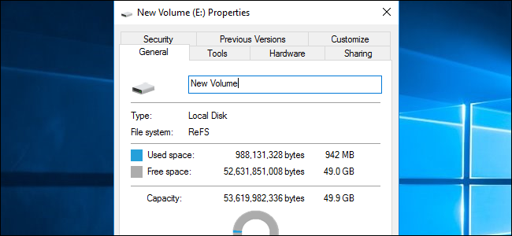

Resilient File System (ReFS) is a type of disk file system that provides a disk storage management platform to Windows server operating systems. ReFS is also known as **Protogon.**

Key features of ReFS include:

* Metadata integrity
* Integrity streams
* Copy on write
* Large volume, file and [directory](http://searchwinit.techtarget.com/sDefinition/0,290660,sid1_gci211957,00.html) sizes
* Storage pooling and [virtualization](http://searchservervirtualization.techtarget.com/definition/virtualization)
* Data striping for performance (similar to [RAID](http://searchstorage.techtarget.com/definition/RAID))
* [Disk scrubbing](http://searchdatamanagement.techtarget.com/sDefinition/0,290660,sid91_gci880972,00.html)
* Resiliency to corruption
* Compatible with shared storage pools

| Feature | ReFS |
| --- | --- |
| Maximum file name length | 255 Unicode characters |
| Maximum path name length | 32K Unicode characters |
| Maximum file size | 35 PB (petabytes) |
| Maximum volume size | 35 PB |

The goals of Microsoft in building ReFS were:

* Maintain a high level of compatibility with NTFS;
* Make it able to verify and auto-correct data
* Optmize for extreme scale
* Make it able to stay always online, even in case of partial corruptions
* Provide a full end-to-end resiliency architecture when used in conjunction with the Storage Spaces feature